To Sand, or Not to Sand: SrRuO3 Pulsed Laser Deposition with Full-Frame Plume Dynamic Imaging

Yichen Guo†,1,2, Liyan Wu†,2, Julian Goddy2, Theo Beers2, Lane Martin4,5,6,7, Jonathan Spanier2,3, Joshua Agar2,*

† Authors contributed equally to this work

1 Department of Materials Science and Engineering, Lehigh University, Bethlehem, PA 18015, USA

2 Department of Mechanical Engineering and Mechanics, Drexel University, Philadelphia, PA 19104, USA

3 Department of Materials Science and Engineering, Drexel University, Philadelphia, PA 19104, USA

4 Department of Materials Science and Engineering, University of California, Berkeley, CA 94720, USA

5 Materials Sciences Division, Lawrence Berkeley National Laboratory, Berkeley, California 94720, USA

6 Department of Materials Science and Nanoengineering, Rice University, Houston, TX 77005, USA

7 Rice Advanced Materials Institute, Rice University, Houston, TX 77005, USA

8 Department of Physics and Astronomy, Rice University, Houston, TX 77005, USA

* Email address: jca92@drexel.edu

# Abstract

High-quality thin films growth via pulsed laser deposition (PLD) requires precise control over plume dynamics, which are influenced by temporal and spatial variations in target surface morphology. We employed a **Full-Frame** **Plume Dynamic Imaging (PDI)** platform to investigate the effects of target surface evolution on plume dynamics and the subsequent impact on film quality and structure. Using SrRuO3 as a model system, we develop automated computer-vision pipelines to extract statistical metrics, such as maximum plume area and incident velocity, under varying conditions, including pre-ablation pulsing and inadvertent target contamination. Repeated ablation improves plume dynamics stability, correlating with enhanced crystalline quality and reduced surface roughness, confirmed by XRD and AFM. Conversely, spatial inhomogeneities, such as target surface contamination, induce instabilities in plume dynamics, resulting in poor crystalline quality, higher surface roughness, and disrupted growth dynamics. Through statistical analysis and heatmap visualization, we establish a direct link between plume stability and thin-film reproducibility. Our findings underscore the necessity of rigorous target surface conditioning and real-time plume diagnostics to enable deterministic control over crystallographic and domain architectures. We posit those stochastic variations in plume dynamics-typically unquantified-constitute a dominant mechanism underlying reproducibility crisis and impediments to extending the design space for bespoke heterostructures and heterointerfaces. Furthermore, the integration of advanced diagnostic tools, such as PDI, offers a robust pathway for achieving precise control in thin-film synthesis, providing a pathway for control of non-equilibrium synthesis processes pervasive in semiconductor manufacturing.

# Introduction

Epitaxial complex oxide thin films have become indispensable in next-generation electronics, catalysis, and energy storage, owing to their tunable electronic, magnetic, and ionic transport properties, which can be precisely engineered through strain, stoichiometry, and defects.1–12 Most of these materials require far-from-equilibrium synthesis methods to achieve complex stoichiometries, finely tuned heterointerfaces, superlattices, and compositional gradients—all of which are essential for enabling emergent functionalities. While many non-equilibrium thin-film synthesis techniques exist, pulsed laser deposition (PLD) is distinguished by its ability to reproducibly deposit complex stoichiometries with relative simplicity in a laboratory setting—some systems even extending this capability to the wafer scale.13 PLD operates by directing a high-intensity pulsed laser onto a target material under low—typically oxidizing—ambient pressure. This process generates a highly energetic plasma plume (5,000-20,000K) that transfers ablated species onto a substrate. The inherently non-equilibrium nature of PLD enables fine-tuning of stoichiometry, crystallographic orientation, and surface morphology through extreme sensitivity to growth parameters, but this same sensitivity also poses significant challenges for high-reproducibility growth, as minor fluctuations in plume dynamics, ambient conditions, or target surface state can substantially impact film quality. 14–19

PLD is highly sensitive to key growth parameters—including laser fluence, repetition rate, ambient gas pressure, and substrate temperature—necessitating precise optimization to regulate plume energetics and adatom surface kinetics, thereby enabling the reproducible growth of high-crystallinity films with controlled defect densities that can be strategically leveraged to engineer emergent functionalities. 18,20–29 In typical PLD processes, only average growth properties are recorded, with little attention given to statistical variances or outliers—such as fluctuations in laser spot profile, stability, and plume dynamics—which can critically influence thin-film quality, microstructural uniformity, and growth reproducibility. 30–33 Instrument-specific constraints, combined with unreported or unaccounted-for exogenic factors, introduce uncertainty into growth processes, resulting structures, and overall reproducibility. As a result, nominally identical experiments—even when conducted by the same researcher in the same laboratory—can produce substantially divergent outcomes without any readily identifiable cause. Furthermore, this is not merely a problem for reproducibility, it also imposes upper bounds on the complexity of the systems which can be realized.

The next paradigm shift in our ability to design bespoke heterostructures will likely arise from the integration of advanced in situ diagnostics with real-time control systems. Plume Dynamic Imaging (PDI) has emerged as a powerful technique for real-time monitoring of plume evolution and subtle variations in growth conditions, enabling data-driven optimization of synthesis protocol.18,34–36 Compared to other in-situ characterization techniques, such as Reflection High-Energy Electron Diffraction (RHEED),27–29,37–39 which probes the structural state of the growing film, PDI directly measures mass transport and plume energetics, providing a powerful framework for elucidating synthesis-structure-property relationships. PDI has enabled investigations into phenomena such as plume rebound and flip-over effects, yielding critical insights into plume-substrate interactions.30,40 Additionally, studies of plume evolution under varying oxygen partial pressures have demonstrated how oxygen regulates film stoichiometry by modulating the formation and dissociation kinetics of transition-metal oxides.15,17 However, previous PDI implementations faced a significant limitation: earlier cameras could capture only a few (<3) frames per pulse,34,40–44 albeit with precisely controlled delay times. As a result, reconstructing complete plume dynamics required stitching together data from multiple pulses under the assumption of minimal plume-to-plume variability—an approach that inherently limited the ability to observe transient, stochastic plume phenomena.

In contrast, full-frame PDI (FF-PDI)-capturing more than 60 frames per laser pulse-enables detailed temporal resolution of plume evolution during ablation, while simultaneously revealing pulse-to-pulse variability that critically impacts growth reproducibility. This enhanced diagnostic capability is particularly valuable for the deposition of complex multi-element oxide heterostructures, such as SrTiO3/LaAlO3 interfaces, and compositionally-graded heterostructures where precise and discontinuous modulation of stoichiometry, substrate temperature, and ambient pressure is essential.37–39 This paradigm shift redefines PLD from a static "Set-It & Forget-It" process, one amenable for dynamic real-time control. FF-PDI provides a pathway for integrating artificial intelligence (AI)—particularly real-time machine learning on edge computing hardware40–54—to enable intelligent control of synthesis dynamics. Recent studies have shown that machine learning algorithms can significantly enhance deposition precision by facilitating automated, real-time recognition of plume characteristics, deterministic feedback control, and dynamic adjustment of growth parameters. Collectively, these advances position PLD as a dynamic, adaptive synthesis platform-analogous to self-driving laboratories, but tailored for real-time control of non-equilibrium growth processes-substantially enhancing reproducibility and establishing a foundation for intelligent, AI-driven materials fabrication.67–70

To explore the novel capabilities afforded by FF-PDI, we have engineered a comprehensive, full-stack PDI platform including hardware designs and software. This system uniquely enables synchronized high-speed plume acquisition, meticulous logging of experimental parameters, and precise quantification of plume dynamics. At its core, our platform leverages the Shimadzu HyperVision HPX-2 high-speed camera, distinguished by its ability to record bursts of up to 128 frames at exceptional temporal resolutions approaching 10 million frames per second.

SrRuO3 thin films were selected as a representative model system due to their widespread use as functional electrode layers in oxide electronics, where their ferromagnetic and conductive properties can be critical for enabling spintronic devices and high-performance heterostructures.67–73 SrRuO3 exhibits several advantageous properties, including temperature-dependent electrical conductivity,29,67, favorable lattice matching to a range of substrates (orthorhombic unit cell: $a=5.56Å, b=5.530Å, c=7.845Å$), and exceptional structural stability, making it highly suitable for integration into multilayer oxide architectures and ferroelectric devices. Furthermore, SrRuO3 displays notable magnetic and electronic phenomena, such as the anomalous Hall effect near 160 K,75 achievable without extrinsic doping in both bulk and epitaxial thin-film forms. Its high thermal stability (up to ~1200 K76) and robust chemical resilience. Finally, SrRuO3 is widely employed as a lattice-matched oxide electrode in ferroelectric devices, where its crystallographic and electronic properties critically influence heterostructure morphology, functional responses, and device performance through mechanisms such as strain transfer and interfacial electronic screening.

Despite its numerous advantages, the reproducible synthesis of SrRuO3 thin films remains highly dependent on experimental expertise and empirical tuning—often accompanied by elements of speculation and a degree of mysticism. Although SrRuO3 is often cited for its relatively broad deposition condition window, synthesis outcomes exhibit substantial variability in literature. While system-level growth parameters-such as laser fluence and substrate temperature-are extensively reported, critical factors such as target defect evolution, target density, and local stoichiometric deviations are often overlooked, despite their substantial influence on ablation dynamics, plume evolution, and ultimately film quality.

A common point of contention among PLD practitioners is whether "to sand, or not to sand" targets prior to growth. Target ablation progressively degrades the surface, modifying ablation dynamics, altering plume energetics, and ultimately impacting film microstructure and stoichiometry. During extended deposition, the initially polished target surface undergoes morphological degradation (e.g., increased roughness, crater formation) and chemical heterogeneity due to plume-induced selective redeposition, selective ablation processes, and laser-induced surface chemical reactions, resulting in localized off-stoichiometric regions. Sanding the target surface between deposition cycles resets the surface morphology by removing damaged layers, thereby reestablishing a uniform and stoichiometrically consistent ablation front. Nevertheless, this approach may introduce greater variations in surface conditions during deposition that potentially affects reproducibility. To mitigate initial variations resulting from mechanical resurfacing, pre-ablation-applying laser pulses to the target prior to film growth-is commonly used to stabilize the ablation front by eliminating transient surface contamination and establishing steady-state plume dynamics. Despite their widespread use, pre-ablation protocols are predominantly guided by empirical heuristics, lacking a rigorous, quantitative framework for assessing their influence on plume dynamics or deposition reproducibility. Consequently, precise characterization and control of target surface evolution-particularly the spatiotemporal inhomogeneities introduced during laser-target interaction-remain essential to achieving deterministic, high-fidelity thin-film growth.

Plume stability is intrinsically linked to the spatial homogeneity of the target surface, which governs the stoichiometry, temporal coherence, and chemical-spatial distributions of the ablation plume. Surface degradation or compositional inhomogeneity can lead to transient deviations in the local ablation rate, resulting in non-stoichiometric transfer, erratic plume dynamics, and fluctuations in deposition flux. These perturbations propagate directly into the film microstructure, altering the crystallinity, interfacial coherence, and electronic transport properties. Remarkably, periodic modulations in plume behavior attributable to target inhomogeneity are often observable even without advanced diagnostics. They are regularly visible to the naked eye, allowing direct observation of significant changes in plume size, which serve as an indicator of the time-averaged emissivity of the plume. Nevertheless, the systematic, high-resolution spatiotemporal mapping of these phenomena remains largely unexplored-primarily due to the absence of diagnostic infrastructure capable of capturing these dynamics in operando.

We investigate two perturbative conditions: (1) varying pre-ablation pulse counts to probe ablation history effects on plume dynamics and film crystallinity, and (2) introducing controlled surface contamination to simulate stoichiometric and defect inhomogeneity. Utilizing a full-frame PDI platform with high-speed imaging, we capture temporally resolved, single-pulse plume dynamics, eliminating the need for ensemble averaging. This enables quantitative extraction of plume velocity, emission area, and intensity, which we correlate with structural and electronic properties of SrRuO3 films grown on SrTiO3. Integration of plume metrics with machine learning provides a framework for real-time feedback and process control, advancing toward autonomous, closed-loop thin-film synthesis. This approach holds the potential to enable access to architected oxide materials previously inaccessible via conventional PLD workflows.

# Results and Discussion

Five SrRuO3/SrTiO3 thin films (denoted as growth G1-G5) were sequentially deposited using the same SrRuO3 target without sanding or restoring the target surface between growth while keeping all other deposition conditions constant. As shown in **Figure 1**a-e, this set of samples was used to evaluate the effects of progressive target surface degradation on film growth. In addition, a separate comparison was made between a film deposited using sample G5 with a film deposited using the same target after subsequent growths of other chemistries (denoted as contaminated growth C-G6), shown in **Figure 1**a-f. We further explore how spatial variations in the target’s surface chemistry and morphology influence the resulting film properties with G5 and C-G6. All films were grown under identical and optimized deposition conditions, with the only variable being the condition of the target surface. The substrate temperature was maintained at $700℃$, and deposition was carried out at a background pressure of $100 mTorr$ in an oxygen atmosphere, using a laser fluence of $1.6 mJ/{cm}^{2}$. These parameters align with reported values in prior studies. The laser spot employed in our experiments had a rectangular shape, measuring 0.93 mm in width and 2.46 mm in height. A computer controlled motion scanner was used to evenly ablate the target surface. Additional experimental details are outlined in the section 6.5.



**Figure 1**: a-f Schematic image of targets used for growths.

X-ray diffraction (XRD) scans were conducted to characterize the structural differences among the films. Reciprocal space maps (RSMs) collected along the SrTiO3 (002) diffraction direction (**Figure 2**a-f) show high intensity and narrow width of SrRuO3 film peaks, indicating all samples are high-quality epitaxial films. From sample G1 to G5, the SrRuO3 diffraction peak becomes increasingly intense and narrower, while the periodic Laue oscillations surrounding the main peak become more distinct. These observations suggest improved crystalline coherence, sharper interfaces, and uniformity in unit cell alignment throughout the deposition sequence. The comparison between sample G5 and C-G6 further reinforces this trend: sample G5 exhibits significantly sharper and more defined features, indicating superior thin film quality compared to c-G6, which suffers from lower crystal coherence likely due to target surface contamination.

To support these findings, $2θ-ω$ scans were performed (**Figure 2**a), revealing consistent SrRuO3 (002) reflections near 45.91° across all samples, with minor variations in peak position. Laue fringes are clearly visible for all samples and were used to estimate film thicknesses: 79.69 nm (G1), 69.33 nm (G2), 69.33 nm (G3), 70.15 nm (G4), 71.65 nm (G5), and 67.24 nm (C-G6). These values confirm nearly constant growth rates across the series, reflecting the uniformity of deposition conditions (12375 laser pulses). Although Laue fringes are not a quantitative measure, they offer qualitative insight into crystalline and interface quality. The increasing prominence of fringes in later depositions (G1–G6)—consistent with the (002) RSMs—suggests enhanced structural coherence, likely due to gradual stabilization of the target surface through repeated ablation.

Notably, sample G4 exhibits distinct peak splitting in both the film and substrate signals, forming two or more clusters. This behavior is attributed to twinning within the SrTiO3 substrate, which introduces slight crystallographic misalignments along the (103) diffraction direction. These twin domains generate multiple peaks along the $Q_{x}$ axis, resulting in the observed splitting in the SrRuO3 thin film signal. It is worth noting that such twinning is commonly observed in commercially available SrTiO3 substrates, particularly those of non-ideal quality.

Crystalline quality was further evaluated through ω rocking curve scans (**Figure 2**b) around SrRuO3 (220) peak, where the full width at half maximum (FWHM) of the diffraction peaks was used as a quantitative metric. A clear trend of decreasing FWHM from sample t1 to t5 indicates progressive improvement in film crystallinity, corroborating the structural trends observed in the RSM and $2θ-ω$ analyses. Comparing samples s1 and s2 again highlights the negative impact of target contamination, with sample s2 exhibiting broader peaks and reduced diffraction intensity.

In addition, RSMs along the asymmetric SrTiO3 (103) reflection (**Figure 2**i-n) confirm the overall high structural quality of the films. The (103) maps show that all SrRuO3 thin films are coherently strained to the SrTiO3 substrate, as evidenced by the alignment of in-plane lattice parameters in reciprocal space. An exception is observed in sample G1, which exhibits partial relaxation, as indicated by asymmetry and peak broadening along the lower $Q_{x}$ direction. The out-of-plane diffraction peaks are distorted from the bulk SrRuO3, indicating that the films are under compressive strain, have defect-induced lattice expansion, or both. Interestingly, consistent $Q_{z}$ positioning across all samples, reinforcing that changes in film quality are more closely tied to smooth, flat interfaces, uniform surface and crystalline coherence.

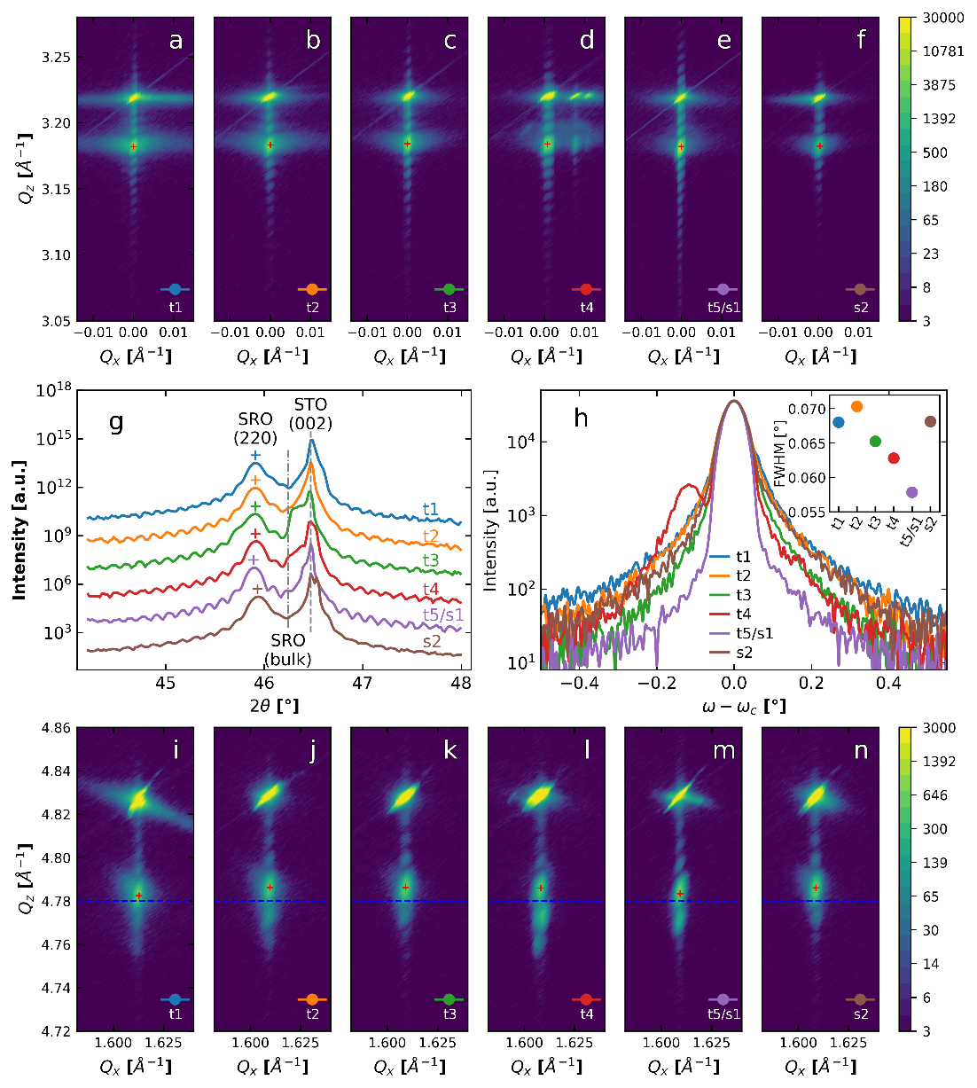

**Figure 2:** X-ray Diffraction (XRD) and reciprocal space mapping (RSM) results. a $ω$- $2θ$ scans for samples G1-G2 with peaks of SrRuO3 thin film, SrTiO3 thin film, and bulk SrRuO3 labeled. b X-ray $ω$-rocking curve scans for samples with full width at half maximum plotted in the inset figure at right top corner. c-h RSMs along 103-diffraction condition for samples t1, t2, t3, t4, t5/s1, s2, respectively. i-n RSMs along 002-diffraction condition for samples t1, t2, t3, t4, t5/s1, and s2, respectively. SrRuO3 peak centers are labeled with red “+” marks in all RSMs. Reference for well-strained SrRuO3 is labelled as blue dashed lines.

Additionally, the surface morphology of the films was characterized using tapping mode atomic force microscopy (AFM) (**Figure 3**). A comparison of samples G1 through G5 reveals a progressive decrease in surface roughness with each subsequent deposition. This trend is accompanied by a noticeable reduction in the density of surface pits or holes. Such holes are typically attributed to insufficient deposition rates. Paradoxically, however, one would expect a slight reduction in growth rate with successive depositions until a steady-state is reached. Counterintuitively—and despite current understanding of plume dynamics evolution—the observed morphology is often proposed to be mitigated by increasing the growth rate, which can be achieved through higher laser repetition rates, increased fluence, or lower ambient pressure.

Further analysis of interpolated line traces from AFM scans (**Figure** g) revealed that these holes likely penetrate to the substrate surface. Such features likely result from non-ideal deposition dynamics during the initial growth stages of SrRuO3. One plausible hypothesis is that initial instability in the deposition conditions leads to unstable plume dynamics, disrupting proper adatom bonding to the SrTiO₃ substrate—an essential requirement for layer-by-layer growth during the early stages. As a result, subsequent adatoms struggle to deposit uniformly due to the persistence holes. Overall, our observations point to a marked improvement in thin-film quality over time, consistent with conclusions drawn from XRD analyses. Additionally, the comparison between samples G1 and G2 suggests that target inhomogeneity plays a significant role in increasing surface roughness.

Distinct differences in growth mode were also observed among the samples. In **Figure 3**a, the surface exhibits an island-like step-flow morphology, where step orientation appears to radiate from the center of circular clusters. This results in hybrid growth behavior combining features of both 2D and 3D growth. In contrast, **Figure 3**c and f show step bunching, where several atomic steps coalesce to form terraces of greater height at irregular intervals. These features are more clearly resolved in the larger-area ($10μm×10μm$) image of **Figure 3**a and the higher-resolution ($5μm×5μm$) scans in Supplementary **Figure** . Deviations from uniform step-flow growth-such as island nucleation or step bunching-are often associated with less desirable film quality.

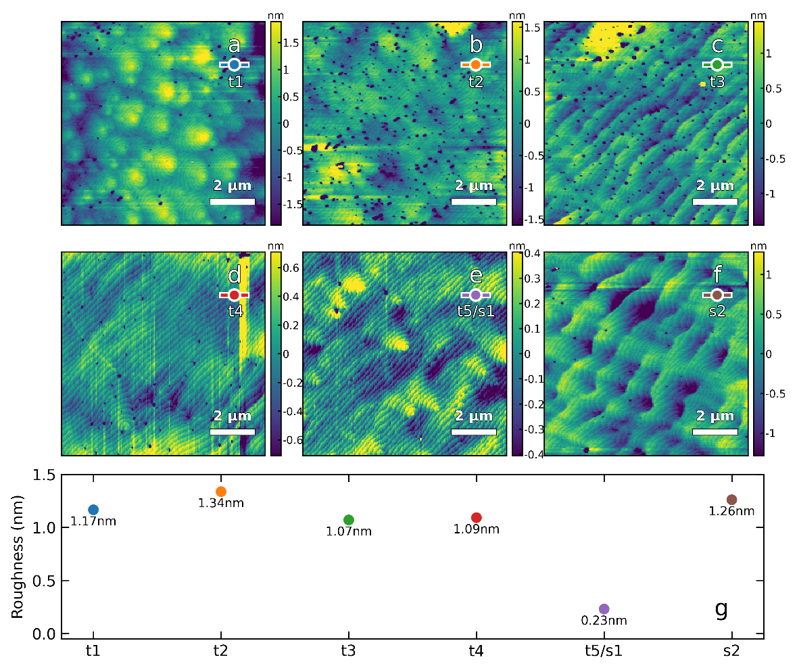

**Figure 3a-f:** AFM scans of $10×10μm$ area of sample t1-t5(s1) and s2. g Surface roughness calculated based on the $10×10μm$ areas of samples.

## Experiment Design for FF-PDI

For all growths, we performed full-frame PDI transverse to the plume axis, as shown in **Figure 4**. A Shimadzu Hyper Vision HPV-X2 high-speed video camera was used for plume imaging. This camera is one of the worlds fastest CCD cameras with an FTCMOS2 image sensor and is capable of capturing up to **2 million frames per second or 1 frame per 500ns** (see Methods). The camera is triggered by the laser pulse signal but operates with a continuous rolling acquisition mode, which compensates for the triggering delays with **200 ns exposures**. To improve consistency and reproducibility in the PLD process, we designed a digital logging system to store the growth parameters and instrument conditions in parallel with PDI data. All records are synchronized with the DataFed data management framework, enabling systematic tracking and retrieval of experimental datasets. A schematic of the PLD logging system is provided in **Figure** . The interior view of the PLD chamber (**Figure 4**) shows that the target and substrate are aligned in a parallel, face-to-face geometry, enabling direct deposition of ablated material. The sample plume image shown in **Figure 4** was acquired using a conventional CCD camera (not the high-speed system) to provide a broader overview of the interior configuration and general plume evolution under RGB imaging over extended timescales.

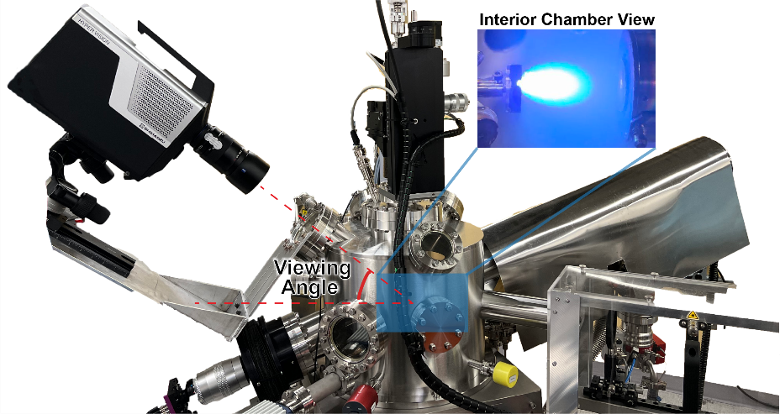

**Figure 4****:** Illustrates the PLD setup and representative experimental design. The diagram includes the PLD chamber, laser system, and the plume imaging configuration. The plume recording camera is positioned at an oblique angle of approximately 45 degrees, overlapping with the optical axis and oriented perpendicular to the plume propagation direction. An interior view of the chamber is also provided, along with a representative plume image, demonstrating the functionality and placement of the plume recording system.

## Plume dynamics introduction

The dynamics of laser-induced plumes play a critical role in understanding the deposition process, particularly in relation to how target surface morphology influences growth. In this study, plume behavior is analyzed using a custom-developed Python package, *Plume-Learn*, which enables precise, automated analysis of plume evolution. The acquired plume data consists of full-frame images with a resolution of 1366 × 768 pixels, and each plume event is captured across 128 frames. Under typical deposition conditions, more than 350 full-frame plumes can be recorded per deposition, depending on the data transfer speed and system buffering capacity.

Based on our observations and previous literature, the plume dynamics can be categorized into four distinct stages:

* Stage 1: Target Ablation: Laser irradiation of the target surface initiates rapid heating, resulting in material removal and the initial formation of a plasma plume.
* Stage 2: Plasma Plume Formation: Continued laser energy input leads to the ejection of particles and energetic species, generating a visible plasma plume above the target.
* Stage 3: Plume Expansion: The plume rapidly expands away from the target, increasing in both spatial extent and velocity as it propagates toward the substrate.
* Stage 4: Plume Incidence on the Substrate: The plume reaches the substrate surface, where various interaction mechanisms may occur, including plume rebound, interfacial scattering, or even target re-coating**.**

This delineation of plume dynamics provides a valuable framework for correlating physical plume behavior with underlying growth mechanisms and contextualizing how variations in target condition may influence film deposition outcomes.

To better describe and quantify intra-plume behavior, we extract several key metrics from each plume sequence, including cross-sectional area, travel distance, and incident velocity. These parameters are visualized using time-resolved line plots in **Figure 5a-c**, showing the time-dependent average plume area, plume distance, and velocity as a function of travel distance, respectively. Each plot represents statistical averages computed from approximately 350 full-frame plume sequences recorded during a single deposition. Shaded regions in the plots indicate the range of variation across plume events, capturing pulse-to-pulse fluctuations.

The temporal evolution of the plume follows the four-stage process described earlier. Since laser ablation occurs on the order of tens of picoseconds-much faster than the 500-nanosecond temporal resolution of our PDI system-only the first available frame at $t=1μs$ captures the laser incidence on the target. This frame corresponds to the initial appearance of the plume, as shown in the embedded plume image in **Figure 5** and representative frames in **Figure** , **Figure** , **Figure** , **Figure** , **Figure**  and **Figure** . As the plasma plume forward propagates, the target ejects high-energy ionized atoms and atomic clusters. The plume reaches its maximum volume and velocity around $t=3μs$, after which it begins to detach from the target surface. It then propagates toward the substrate, completing the material transfer process. Under certain conditions, such as reduced ambient pressure or elevated laser fluence, plume rebound may occur during substrate interaction. The incident velocity is estimated by averaging the speed of the plume prior to the point at which it becomes untraceable in the recorded sequence.

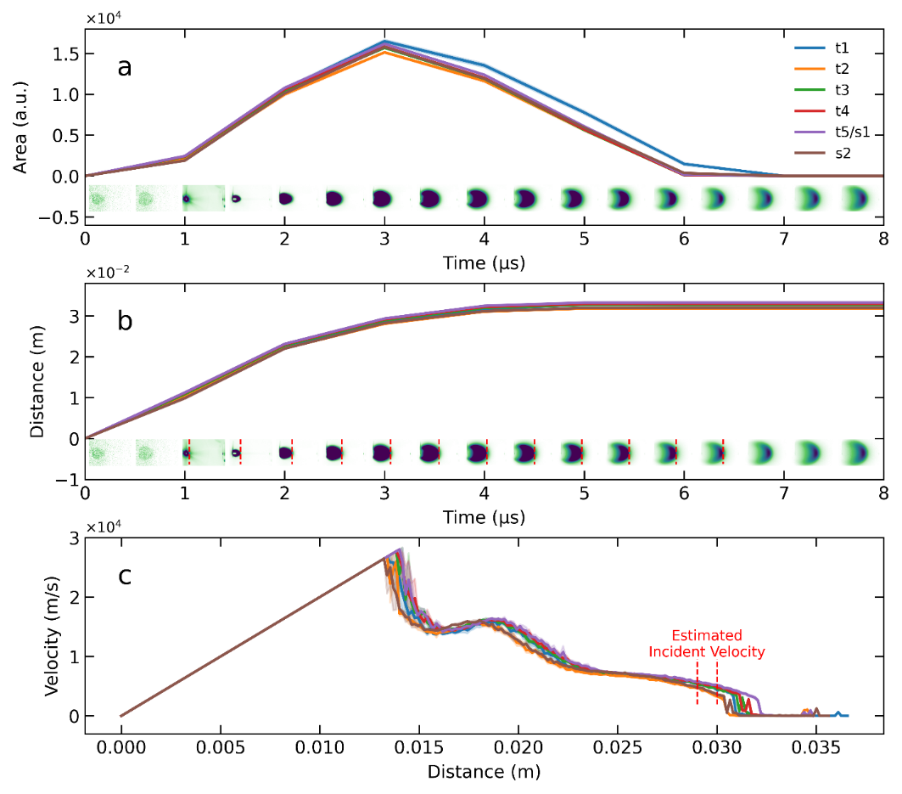

**Figure 5:** Plume sample frames and the plume metrics for plume description and evaluation. **a** Plume area of the plumes for sample t1-t5(s1) and s2 in time. A series of plumes pictures are included as a example to undertstand plume area. **b** Plume transport distance in time. Example plumes pictures are also with mark of the plume position. **c** Plume transport velocity in distance. The red dashed lines marked the range of velocity used for estimated incident velocity calculation.

As observed, the differences between growths are relatively minor when averaged over all plumes during the entire deposition process. This suggests consistent growth dynamics and supports the robustness and reliability of our in-situ PDI measurements, as well as the analysis workflow implemented in the *Plume-Learn* Python package. However, it remains unclear whether averaging may decimate meaningful variations. The reduction of data through temporal averaging could potentially mask transient or anomalous individual plume dynamics that may influence film properties.

To address this concern, we apply statistical analysis methods-including plume variation analysis and anomaly detection to identify subtle differences in plume behavior that might correlate with changes in film structure or quality. Specifically, we extract and summarize two key metrics-maximum plume cross-sectional area and incident velocity-for each individual plume. These distributions are used to evaluate two main aspects: (1) the relationship between plume dynamics and the evolving target surface condition over time, and (2) the correlation between plume behavior and spatial variation across the target surface.

## Plume dynamics correlation with time-resolved target surface

To investigate how laser ablation-induced changes in target surface morphology affect SrRuO3 thin film quality, we analyzed plume dynamics across the sequentially deposited samples G1-G5 (with G5 also denoted as S1). Although the average plume area, travel distance, and incident velocity appear broadly similar across these samples, this apparent consistency highlights the need for statistical evaluation to uncover subtle but meaningful variations in plume behavior during deposition. For this purpose, we focused on two key metrics: **maximum plume area** and **incident velocity**. These metrics are statistically visualized using violin plots in .

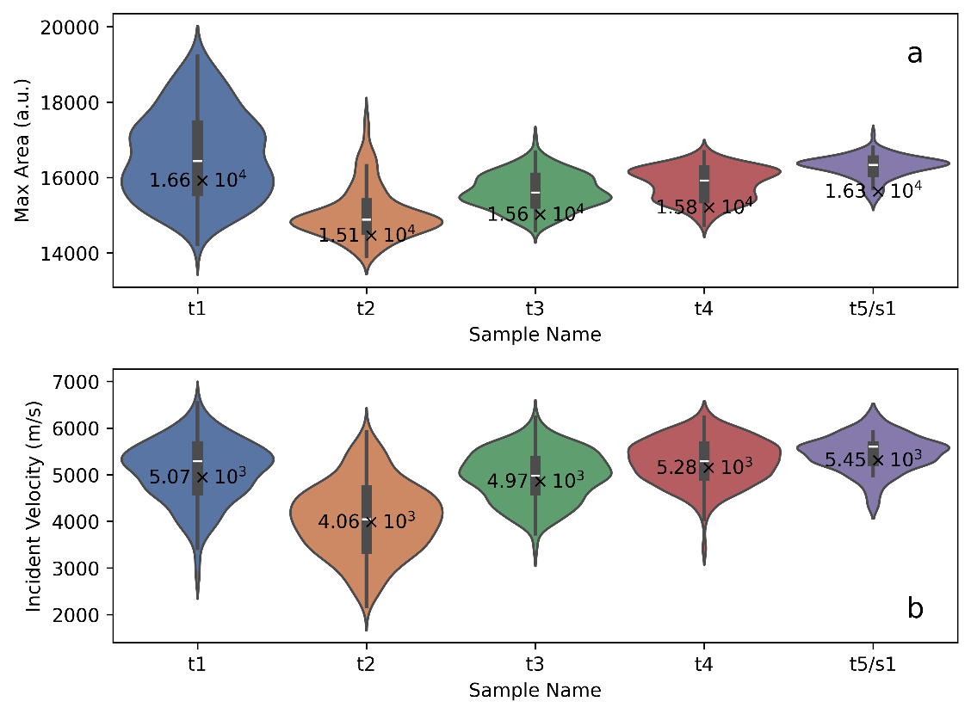

**Figure 6** Violin plots of plume key metrics between sample t1-t5(s1). **a** Statistical summary for max area of plumes through the deposition process. **b** Statistical summary of plume incident velocity through the deposition process.

The maximum plume area was determined by analyzing the spatial expansion of the plume over time from high-resolution image sequences (1366 × 768 pixels per frame). This parameter reflects the extent of material ejection and the energy coupling efficiency between the laser and the target. Incident velocity was calculated as the average speed of the plume near the end of its visible trajectory, just before dissipation due to energy loss. Specifically, we averaged the velocity when the plume traveled between 2.8 and 2.9 cm from the target surface. By computing these metrics for each individual plume, we generated statistical distributions indexed by plume number. These summaries serve as valuable indicators of plume stability, helping to identify anomalies and trends in dynamic behavior throughout the deposition process.

Our results reveal a progressive decrease in the pulse-to-pulse standard deviation of both maximum area and incident velocity from t1 to t5/s1. This trend indicates increasingly stable plume behavior with continued use of the same target. The observed stabilization is likely a result of the evolving target surface morphology under repeated laser ablation, which leads to more uniform plume generation. These improvements in plume consistency correlate strongly with enhancements in thin film quality, including higher crystallinity and reduced defect density. To further support this observation, we provide heat maps of plume maximum area and incident velocity in **Figure 7**, which visually demonstrate increased plume stability across the deposition sequence. In particular, sample t1 exhibits clear periodic fluctuations in plume behavior, suggesting plume behavior instability caused by non-uniform target surface morphology during its growth.

Notably, unstable plume dynamics, which is characterized by significant variations in maximum area and incident velocity, can disrupt growth processes, result in defects, and alter chemistry. These instabilities may lead to undesirable stoichiometric deviations in the plume composition and inconsistencies in substrate surface dynamics during crystallization, which may alter the structure and growth modes of the heterostructures. This relationship highlights the importance of experiment conditions’ stability in determining the resulting thin-film properties.

While our findings demonstrate a clear correlation between target surface evolution and plume behavior, our analysis of pre-ablation processes remains qualitative. Factors such as target material composition, microstructure, and laser fluence may all influence the evolution of the target surface in ways that vary across different systems. As such, it is difficult to offer specific procedural guidelines for pre-ablation treatment at this stage. Nonetheless, the broader relationship between target conditioning and plume stability is evident. Overall, this analysis highlights the critical role of in-situ characterization in achieving reliable and reproducible thin film synthesis. By providing real-time feedback on plume dynamics, techniques such as PDI allow for early detection and mitigation of growth instabilities, facilitating the deposition of thin films with improved structural and functional properties.

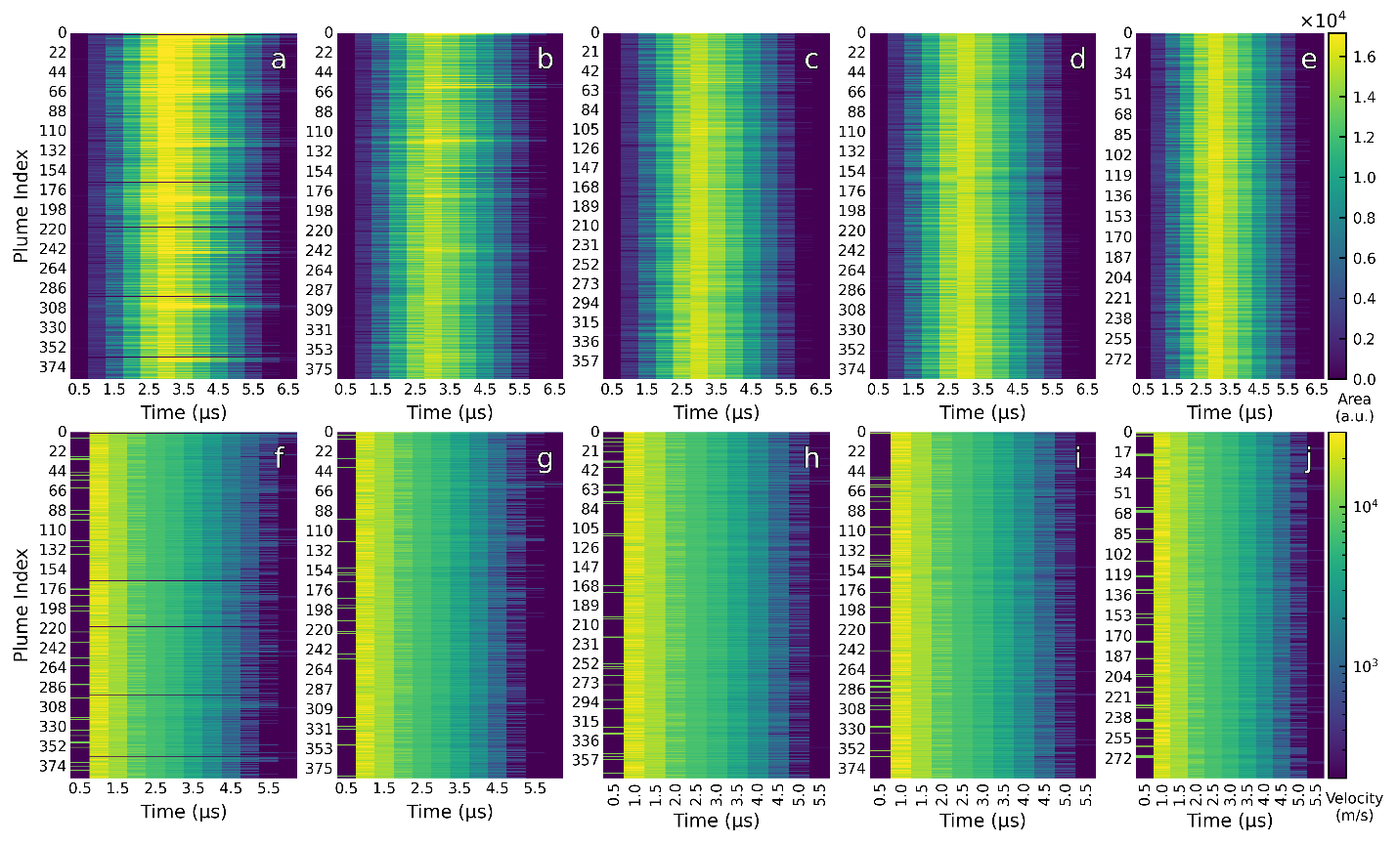

**Figure 7: a-e** Heatmaps of plume max area for sample t1-t5/s2. **f-j** Heatmaps of plume incident velocity for sample t1-t5/s2.

## Plume dynamics correlation with spatial variation target surface

To further investigate the origins of plume dynamics variability, we examined the correlation between the plume behavior and target surface morphology. We hypothesize that non-uniform ablation due to target surface contamination or morphology can introduce fluctuations in plume energy, composition, and deposition efficiency. These fluctuations may, in turn, influence thin film quality. To test this hypothesis, we compared two samples: sample s2, which was deposited using a target with localized surface contamination, and sample t5/s1, which was grown under identical conditions but with a more uniform target surface.

As described in the previous section, sample s2 exhibited degraded structural quality, characterized by increased surface roughness, a broader SrRuO3 diffraction peak, and less pronounced Laue fringes. In contrast, sample t5/s1 showed clear signs of superior film quality. To evaluate whether plume behavior reflects these differences, we applied statistical analysis to plume dynamics and visualized the results using violin plots and heat maps (**Figure 8**).

The violin plots of maximum plume area and incident velocity show broader and more variable distributions for sample s2 compared to t5/s1. These results suggest that plume dynamics were less stable throughout the deposition of s2, consistent with its poorer structural quality. A more detailed time-resolved analysis, presented in the form of heat maps, offers further insight. For sample s2, the heat maps reveal periodic increases in plume area and incident velocity, indicating intermittent plume instability linked to spatial inhomogeneities on the target. In contrast, this variability is significantly reduced in sample t5/s1, which exhibits a more consistent and uniform plume profile over time. These observations suggest that spatial irregularities on the target surface can disrupt plume formation in a manner similar to what is observed during the early stages of target usage, before the surface becomes conditioned through repeated ablation. In both cases, such instabilities result in plume fluctuations that negatively impact deposition consistency and film quality.

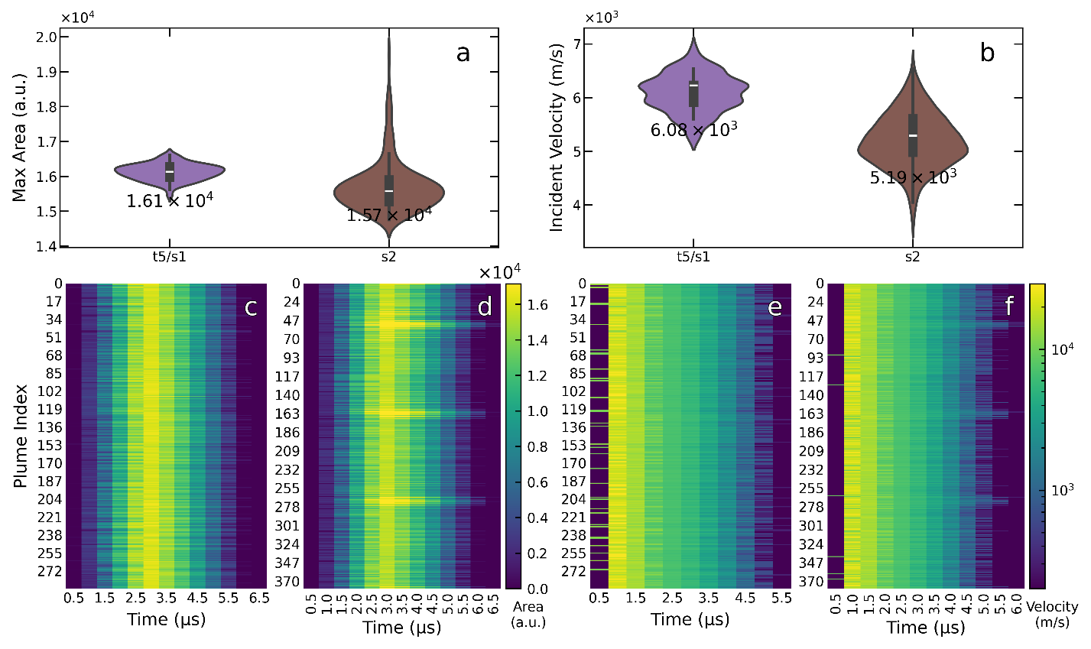

**Figure 8:** Statistical analysis of plume dynamics. **a, b** Violin plots showing maximum area and incident velocity for samples t5/s1 and s2. **c, d** Heat maps of maximum area across plume indices for samples t5/s1 and s2. **e, f** Heat maps of incident velocity across plume indices for samples t5/s1 and s2. Each heatmap plot the plume metric as the color intensity in “viridis” color palette, with plume index and plume evolving time as the x axis y axis, respectively.

This study demonstrates a systematic exploration of the interplay between target surface morphology, laser-induced plume dynamics, and the resulting structural quality of SrRuO3 thin films grown by pulsed laser deposition (PLD). By implementing a high-speed, in-situ Plume Dynamic Imaging (PDI) system and a supporting analysis framework (Plume-Learn), we captured the evolution of plume behavior at the pulse-by-pulse level and correlated it with film quality across a range of target conditions. Our results reveal that the condition of the target surface (both over time and across spatial regions) plays a critical role in determining plume stability. As the target is gradually conditioned through repeated laser ablation, plume dynamics become increasingly stable, which coincides with improvements in film crystallinity, surface morphology, and interface coherence. In contrast, spatial inhomogeneities or surface contamination on the target lead to irregular plume characteristics, including fluctuations in cross-sectional area and velocity, which correlate with degraded film quality. Statistical visualization enabled a more nuanced assessment of plume variability, revealing patterns that would be obscured by simple averaging. These analyses provided insight into the underlying mechanisms that govern reproducibility in thin-film deposition, offering both qualitative and quantitative evidence for the importance of stable plume behavior.

This work highlights the critical value of in-situ diagnostics not only for real-time process monitoring but also as a foundational element for future closed-loop control strategies. By providing immediate feedback on the physical processes driving film growth, tools like PDI allow researchers to identify instabilities before they manifest as structural defects. In the broader context of thin-film research, the insights gained here contribute to a deeper understanding of how target conditions and deposition dynamics influence material properties, and they help establish best practices for producing high-quality complex oxide thin films. Looking ahead, the methodology presented in this study lays the groundwork for integration with data-driven optimization and machine learning-assisted synthesis. As such approaches mature, they hold the potential to further automate and refine the thin-film growth process, enabling more precise control over structure, stoichiometry, and functional properties in next-generation oxide heterostructures.

# Conclusion

This study presents a detailed investigation into how target surface morphology directly impacts plume dynamics and thin-film quality in PLD of SrRuO3, leveraging a high-speed, full-frame PDI system. Through pulse-by-pulse analysis of plume behavior, we establish that both temporal conditioning and spatial uniformity of the target surface are crucial for achieving stable plume characteristics. These, in turn, correlate strongly with improvements in film crystallinity, surface smoothness, and structural coherence.

The findings underscore the importance of real-time diagnostic tools in modern thin-film synthesis workflows. Plume instability, whether stemming from early ablation irregularities or localized surface contamination, was shown to degrade film quality via fluctuations in plume energy and stoichiometry. By applying statistical analyses and machine learning-enabled metrics, we identified subtle plume variations that conventional averaging might obscure, thereby providing a more nuanced understanding of reproducibility challenges in PLD.

Ultimately, this work positions PDI as a critical enabler for autonomous, closed-loop control in thin-film growth, offering actionable insights that can be generalized to other complex oxide systems. The methodologies developed here, combining advanced imaging, statistical modeling, and data-driven analysis, pave the way for predictive, adaptive, and highly reproducible oxide film synthesis, thus supporting the broader vision of intelligent materials fabrication platforms.

# Method

*Sample Preparation.* Heteroepitaxial SrRuO3 thin films were grown from single crystal SrRuO3 (001) targets on SrTiO3 (001) substrates by PLD at 700 $°$ C in a background pressure of 100 mTorr with a O2 atmosphere. The laser fluence is 1.6 $J/{cm}^{2}$ with a spot size 2.28 ${mm}^{2}$ (0.93 $mm$ width and 2.46 $mm$ height), and the laser frequency/repetition rate is 5 $Hz$. We deposit single SrRuO3 thin film with 12357 pulses for thickness at around 60 $nm$ based on optimized process. And the target follows a scanning movement that will move horizontally at the speed of 5 $mm/s$ followed by movement vertically in 1.5 $mm/s$ when target reaches the end of each line. Following growth, samples were cooled to room temperature in oxygen atmosphere with pressure up to $3×{10}^{5} mTorr$. For samples t1 through t5, the same SrRuO3 target was used without polishing between depositions in order to study the effects of target surface evolution. In contrast, sample S2 was deposited using a target that had been intentionally contaminated through intermittent use over the course of a month with other oxide materials, such as SrTiO₃, in order to evaluate the effects of surface inhomogeneity.

*X-ray diffraction.* SrRuO3 thin films are characterized by X-ray diffraction (Empyrean Gen 3, Malvern Panalytical) using Cu-Kα radiation 273 (λ = 1.5406 Å) from Malvern Panalytical for the omega-2theta scan, omega rocking curve scan, and reciprocal space mapping (RSM).

*Scanning probe microscopy.* Thin films surface morphology is characterized by Atomic Force Microscopic Cypher from Oxford Instrument.

# Reference

1. Kelley, K. P. et al. Thickness and strain dependence of piezoelectric coefficient in BaTiO3 thin films. Phys. Rev. Mater. **4**, 024407 (2020).

2. Bain, A. K. & Chand, P. Ferroelectrics: Principles and Applications. (Wiley-VCH Verlag, Weinheim, Germany, 2017). doi:10.1002/9783527805310.

3. Agar, J. C. New modalities of strain-based engineering of ferroelectrics: Domain structure and properties of PbZr1−xTixO3 thin films. (University of Illinois at Urbana-Champaign, 2015).

4. Xu, R. et al. Strain-induced room-temperature ferroelectricity in SrTiO3 membranes. Nat. Commun. **11**, 3141 (2020).

5. Haeni, J. H. et al. Room-temperature ferroelectricity in strained SrTiO3. Nature **430**, 758–761 (2004).

6. Pesquera, D. et al. Beyond substrates: Strain engineering of ferroelectric membranes. Adv. Mater. **32**, e2003780 (2020).

7. Eason, R. Pulsed Laser Deposition of Thin Films: Applications-Led Growth of Functional Materials. (John Wiley & Sons, Nashville, TN, 2007). doi:10.1002/0470052120.

8. Damodaran, A. R. et al. Three-State Ferroelastic Switching and Large Electromechanical Responses in PbTiO3 Thin Films. Adv. Mater. **29**, (2017).

9. Agar, J. C. et al. Tuning Susceptibility via Misfit Strain in Relaxed Morphotropic Phase Boundary PbZr1-xTixO3 Epitaxial Thin Films. Advanced Materials Interfaces **1**, 1–8 (2014).

10. Guo, Y. et al. Predicting pulsed-laser deposition SrTiO3 homoepitaxy growth dynamics using high-speed reflection high-energy electron diffraction. ACS Appl. Mater. Interfaces **17**, 24485–24493 (2025).

11. Saremi, S., Kim, J., Ghosh, A., Meyers, D. & Martin, L. W. Defect-Induced (Dis)Order in Relaxor Ferroelectric Thin Films. Phys. Rev. Lett. **123**, 207602 (2019).

12. Saremi, S. et al. Electronic transport and ferroelectric switching in ion‐bombarded, defect‐engineered BiFeO3 thin films. Adv. Mater. Interfaces **5**, 1700991 (2018).

13. Solmates B.V. (n.d.). Homepage. https://www.solmates.nl/.

14. Schou, J. Physical aspects of the pulsed laser deposition technique: The stoichiometric transfer of material from target to film. Appl. Surf. Sci. **255**, 5191–5198 (2009).

15. Liu, G. Z., Lei, Q. Y. & Xi, X. X. Stoichiometry of SrTiO3 films grown by pulsed laser deposition. Appl. Phys. Lett. **100**, 202902 (2012).

16. Siebenhofer, M., Huber, T., Artner, W., Fleig, J. & Kubicek, M. Substrate stoichiometry changes during pulsed laser deposition: a case study on SrTiO3. Acta Mater. **203**, 116461 (2021).

17. Lee, H. N., Ambrose Seo, S. S., Choi, W. S. & Rouleau, C. M. Growth control of oxygen stoichiometry in homoepitaxial SrTiO3 films by pulsed laser epitaxy in high vacuum. Sci. Rep. **6**, 19941 (2016).

18. Christen, H. M. & Eres, G. Recent advances in pulsed-laser deposition of complex oxides. J. Phys. Condens. Matter **20**, 264005 (2008).

19. Maria, J.-P., Trolier-McKinstry, S., Schlom, D. G., Hawley, M. E. & Brown, G. W. The influence of energetic bombardment on the structure and properties of epitaxial SrRuO3 thin films grown by pulsed laser deposition. J. Appl. Phys. **83**, 4373–4379 (1998).

20. Fang, X. & Kobayashi, T. Characterization of SrRuO3 thin film grown by laser ablation at temperatures above 400 °C. J. Appl. Phys. **90**, 162–166 (2001).

21. Lu, W. et al. Effect of oxygen vacancies on the electronic structure and transport properties of SrRuO3 thin films. J. Appl. Phys. **113**, 17E125 (2013).

22. Zakharov, N. D., Satyalakshmi, K. M., Koren, G. & Hesse, D. Substrate temperature dependence of structure and resistivity of SrRuO3 thin films grown by pulsed laser deposition on (100) SrTiO3. J. Mater. Res. **14**, 4385–4394 (1999).

23. Michely, T. & Krug, J. Layer-By-Layer Growth and Growth Manipulation. in Islands, Mounds and Atoms (eds. Michely, T. & Krug, J.) 227–252 (Springer Berlin Heidelberg, Berlin, Heidelberg, 2004). doi:10.1007/978-3-642-18672-1_5.

24. Ito, A., Masumoto, H. & Goto, T. Microstructure and Electrical Conductivity of Epitaxial SrRuO3 Thin Films Prepared on (001), (110) and (111) SrTiO3 Substrates by Laser Ablation. Mater. Trans. **48**, 227–233 (2007).

25. Daryapurkar, A. S., Kolte, J. T. & Gopalan, P. Growth of pseudocubic perovskite-type SrRuO3 thin films on quartz substrate using pulsed laser deposition method. J. Mater. Sci.: Mater. Electron. **24**, 4698–4703 (2013).

26. Meng, J., Chen, Z. & Jiang, A. Investigation of the growth mechanism of SrRuO3 thin films fabricated by pulsed laser deposition. Jpn. J. Appl. Phys. **54**, 055502 (2015).

27. Deng, Z. et al. Quasi-Two-Dimensional Ferromagnetic SrRuO3 Grown by Pulsed Laser Deposition with Layer-by-Layer Growth Fashion. Advanced Materials Interfaces **9**, 2201371 (2022).

28. Choi, J., Eom, C. B., Rijnders, G., Rogalla, H. & Blank, D. H. A. Growth mode transition from layer by layer to step flow during the growth of heteroepitaxial SrRuO3 on (001) SrTiO3. Appl. Phys. Lett. **79**, 1447–1449 (2001).

29. Koster, G. et al. Structure, physical properties, and applications of SrRuO3 thin films. Rev. Mod. Phys. **84**, 253–298 (2012).

30. Ojeda-G-P, A., Schneider, C. W., Döbeli, M., Lippert, T. & Wokaun, A. The flip-over effect in pulsed laser deposition: Is it relevant at high background gas pressures? Appl. Surf. Sci. **357**, 2055–2062 (2015).

31. Craciun, F., Lippert, T. & Dinescu, M. Pulsed Laser Deposition: Fundamentals, Applications, and Perspectives. in Handbook of Laser Micro- and Nano-Engineering (ed. Sugioka, K.) 1–33 (Springer International Publishing, Cham, 2020). doi:10.1007/978-3-319-69537-2_27-1.

32. Shepelin, N. A. et al. A practical guide to pulsed laser deposition. Chem. Soc. Rev. **52**, 2294–2321 (2023).

33. Haider, A. J., Alawsi, T., Haider, M. J., Taha, B. A. & Marhoon, H. A. A comprehensive review on pulsed laser deposition technique to effective nanostructure production: trends and challenges. Opt. Quantum Electron. **54**, 1–25 (2022).

34. Schneider, C. W. & Lippert, T. PLD plasma plume analysis: a summary of the PSI contribution. Appl. Phys. A: Mater. Sci. Process. **129**, 138 (2023).

35. Bulgakova, N. M., Bulgakov, A. V. & Bobrenok, O. F. Double layer effects in laser-ablation plasma plumes. Phys. Rev. E Stat. Phys. Plasmas Fluids Relat. Interdiscip. Topics **62**, 5624–5635 (2000).

36. Ojeda-G-P, A., Schneider, C. W., Lippert, T. & Wokaun, A. Pressure and temperature dependence of the laser-induced plasma plume dynamics. J. Appl. Phys. **120**, 225301 (2016).

37. Gura, A., Bertino, G., Bein, B. & Dawber, M. Transition regime from step-flow to step-bunching in the growth of epitaxial SrRuO3 on (001) SrTiO3. Appl. Phys. Lett. **112**, 182902 (2018).

38. Rijnders, G., Blank, D. H. A., Choi, J. & Eom, C.-B. Enhanced surface diffusion through termination conversion during epitaxial SrRuO3 growth. Appl. Phys. Lett. **84**, 505–507 (2004).

39. Yichen Guo, Peter Meisenheimer, Shuyu Qin, Xinqiao Zhang, Julian Goddy, Ramamoorthy Ramesh, Lane W. Martin, and Joshua C. Agar. Predicting pulsed-laser deposition SrTiO3 homoepitaxy growth dynamics using high-speed reflection high-energy electron diffraction. ACS Appl. Mater. Interfaces **17**, 24485–24493 (2025).

44. Schou, J., Amoruso, S. & Lunney, J. G. Plume Dynamics. in Laser Ablation and its Applications 67–95 (Springer US, Boston, MA, 2007). doi:10.1007/978-0-387-30453-3_4.

45. Aruta, C. et al. Pulsed laser deposition of SrCuO2/CaCuO2 superlattices. Appl. Phys. Lett. **68**, 926–928 (1996).

46. Blank, D. H. A., Rijnders, G. J. H. M., Koster, G. & Rogalla, H. A New Approach in Layer-by-layer Growth of Oxide Materials by Pulsed Laser Deposition. J. Electroceram. **4**, 311–318 (2000).

47. Malik, V. K. et al. Pulsed laser deposition growth of heteroepitaxial YBa2Cu3O7/La0.67Ca0.33MnO3superlattices on NdGaO3and Sr0.7La0.3Al0.65Ta0.35O3substrates. Phys. Rev. B Condens. Matter Mater. Phys. **85**, 054514 (2012).

48. Baldi, T. et al. Reliable edge machine learning hardware for scientific applications. in 2024 IEEE 42nd VLSI Test Symposium (VTS) 1–5 (IEEE, 2024). doi:10.1109/vts60656.2024.10538639.

49. Forelli, R. F., Shi, R., Ogrenci, S. & Agar, J. A High Level synthesis methodology for dynamic monitoring of FPGA ML accelerators. in 2024 IEEE 42nd VLSI Test Symposium (VTS) 1–5 (IEEE, 2024). doi:10.1109/vts60656.2024.10538570.

50. Wei, Y. et al. Low latency optical-based mode tracking with machine learning deployed on FPGAs on a tokamak. Rev. Sci. Instrum. **95**, 073509 (2024).

51. Islam, K. et al. Real-time cell sorting with scalable in situ FPGA-accelerated deep learning. arXiv [cs.LG] (2025).

52. Kaliyev, A. T. et al. Rapid Fitting of Band-Excitation Piezoresponse Force Microscopy Using Physics Constrained Unsupervised Neural Networks. in AI for Accelerated Materials Design - NeurIPS 2023 Workshop (2023).

53. St. John, J. et al. Real-time artificial intelligence for accelerator control: A study at the Fermilab Booster. Phys. Rev. Accel. Beams **24**, 104601 (2021).

54. Badea, A. et al. Intelligent pixel detectors: Towards a radiation hard ASIC with on-chip machine learning in 28 nm CMOS. arXiv [physics.ins-det] (2024).

55. Rankin, D. S. et al. FPGAs-as-a-Service Toolkit (FaaST). arXiv [physics.comp-ph] (2020) doi:10.1109/H2RC51942.2020.00010.

56. Heintz, A. et al. Accelerated charged particle tracking with graph neural networks on FPGAs. arXiv [physics.ins-det] (2020).

57. Duarte, J. et al. FastML science benchmarks: Accelerating real-time scientific edge machine learning. arXiv [cs.LG] (2022).

58. Ahmad Khan, S., Mitra, J. & Nayak, T. K. FPGA based high speed DAQ systems for HEP experiments: Potential challenges. in Springer Proceedings in Physics 83–89 (Springer International Publishing, Cham, 2023). doi:10.1007/978-3-031-19268-5_11.

59. Mitra, J. & Nayak, T. Reconfigurable very high throughput low latency VLSI (FPGA) design architecture of CRC 32. Integration (Amst.) **56**, 1–14 (2017).

60. Khan, S. A., Mitra, J. & Nayak, T. K. Development of FPGA based phase alignment logic for the high speed protocol in HEP Experiments. Comput. Phys. Commun. **259**, 107649 (2021).

61. Mandal, S. et al. FPGA based novel high speed DAQ system design with error correction. in 2015 IEEE Computer Society Annual Symposium on VLSI (IEEE, 2015). doi:10.1109/isvlsi.2015.80.

62. Mitra, J. & Nayak, T. K. An FPGA-Based Phase Measurement System. IEEE Trans. Very Large Scale Integr. VLSI Syst. **26**, 133–142 (2018).

63. Abolhasani, M. & Kumacheva, E. The rise of self-driving labs in chemical and materials sciences. Nat. Synth. **2**, 483–492 (2023).

64. Häse, F., Roch, L. M. & Aspuru-Guzik, A. Next-generation experimentation with self-driving laboratories. Trends Chem. **1**, 282–291 (2019).

65. Tom, G. et al. Self-driving laboratories for chemistry and materials science. Chem. Rev. **124**, 9633–9732 (2024).

66. Roch, L. M. et al. ChemOS: Orchestrating autonomous experimentation. Sci. Robot. **3**, eaat5559 (2018).

67. Klein, L. et al. Anomalous Spin Scattering Effects in the Badly Metallic Itinerant Ferromagnet SrRuO3. Phys. Rev. Lett. **77**, 2774–2777 (1996).

68. Samanta, K., Ležaić, M., Blügel, S. & Mokrousov, Y. Tailoring the anomalous Hall effect of SrRuO3 thin films by strain: A first principles study. J. Appl. Phys. **129**, 093904 (2021).

69. Agrestini, S. et al. Electronic and spin states ofSrRuO3thin films: An x-ray magnetic circular dichroism study. Phys. Rev. B Condens. Matter Mater. Phys. **91**, 075127 (2015).

70. Gu, Y. et al. An overview of SrRuO3-based heterostructures for spintronic and topological phenomena. J. Phys. D Appl. Phys. **55**, 233001 (2022).

71. Cuoco, M. & Di Bernardo, A. Materials challenges for SrRuO3: From conventional to quantum electronics. APL Mater. **10**, (2022).

72. Jeong, S. G., Oh, J. Y., Hao, L., Liu, J. & Choi, W. S. Correlated quantum phenomena of spin–orbit coupled perovskite oxide heterostructures: Cases of SrRuO3 and SrIrO3 based artificial superlattices. Adv. Funct. Mater. **33**, 2301770 (2023).

73. Mackenzie, A. P. et al. Observation of quantum oscillations in the electrical resistivity of SrRuO3. Phys. Rev. B Condens. Matter **58**, R13318–R13321 (1998

# Supporting Information

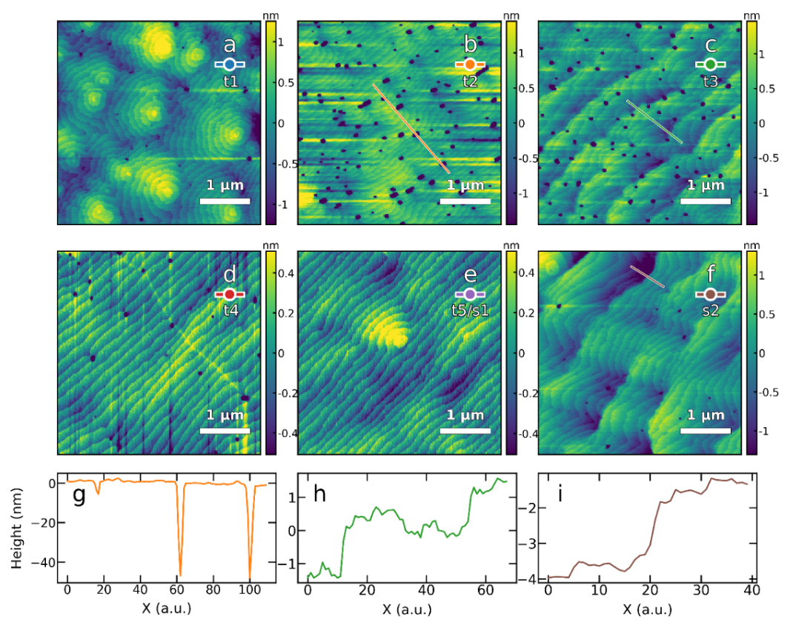

**Figure S1 a-f** AFM scans of $5×5μm$ area of samplet1-t5(s1) and s2**. g-i** Surface cross section along the indicated line for sample t2, t3 and s2.

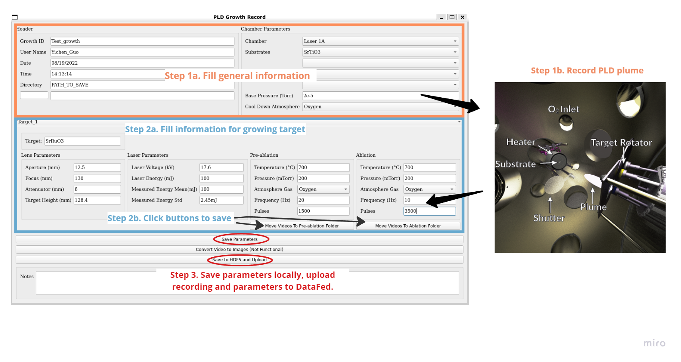

**Figure S2:** Diagram illustration of PLD digital logging system with step procedures.

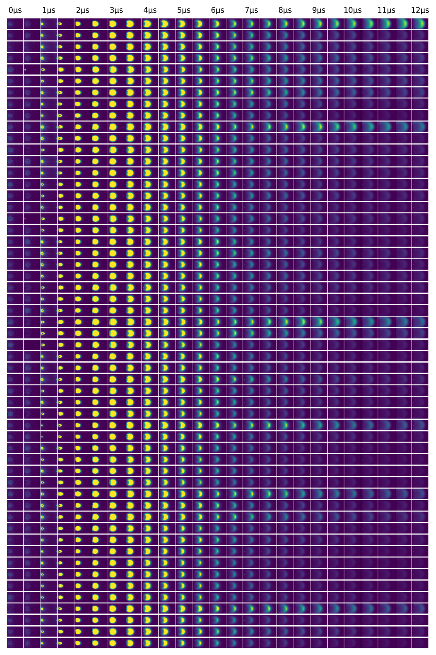

**Figure S3** Samples of plume frames for sample t1.



**Figure S4** Samples of plume frames for sample t2.



**Figure S5** Samples of plume frames for sample t3.



**Figure S6** Samples of plume frames for sample t4.



**Figure S7** Samples of plume frames for sample t5/s1.



**Figure S8** Samples of plume frames for sample s2.

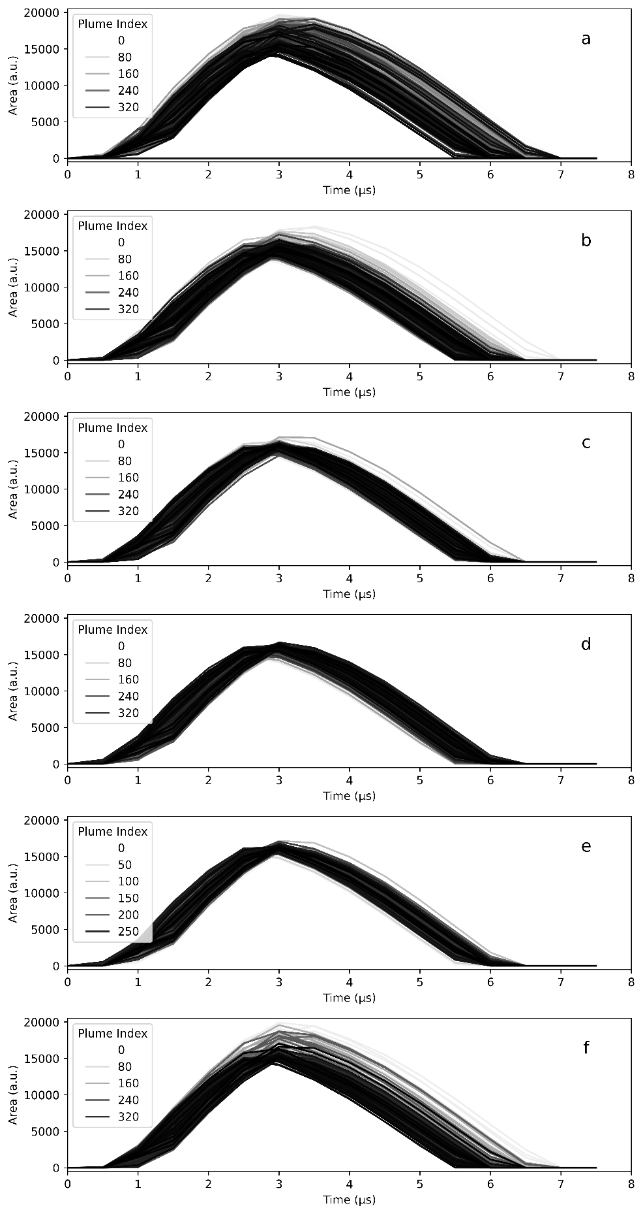

**Figure S9** a-f Plume area with time with indexed plume history for sample t1-t5/s1 and s2.

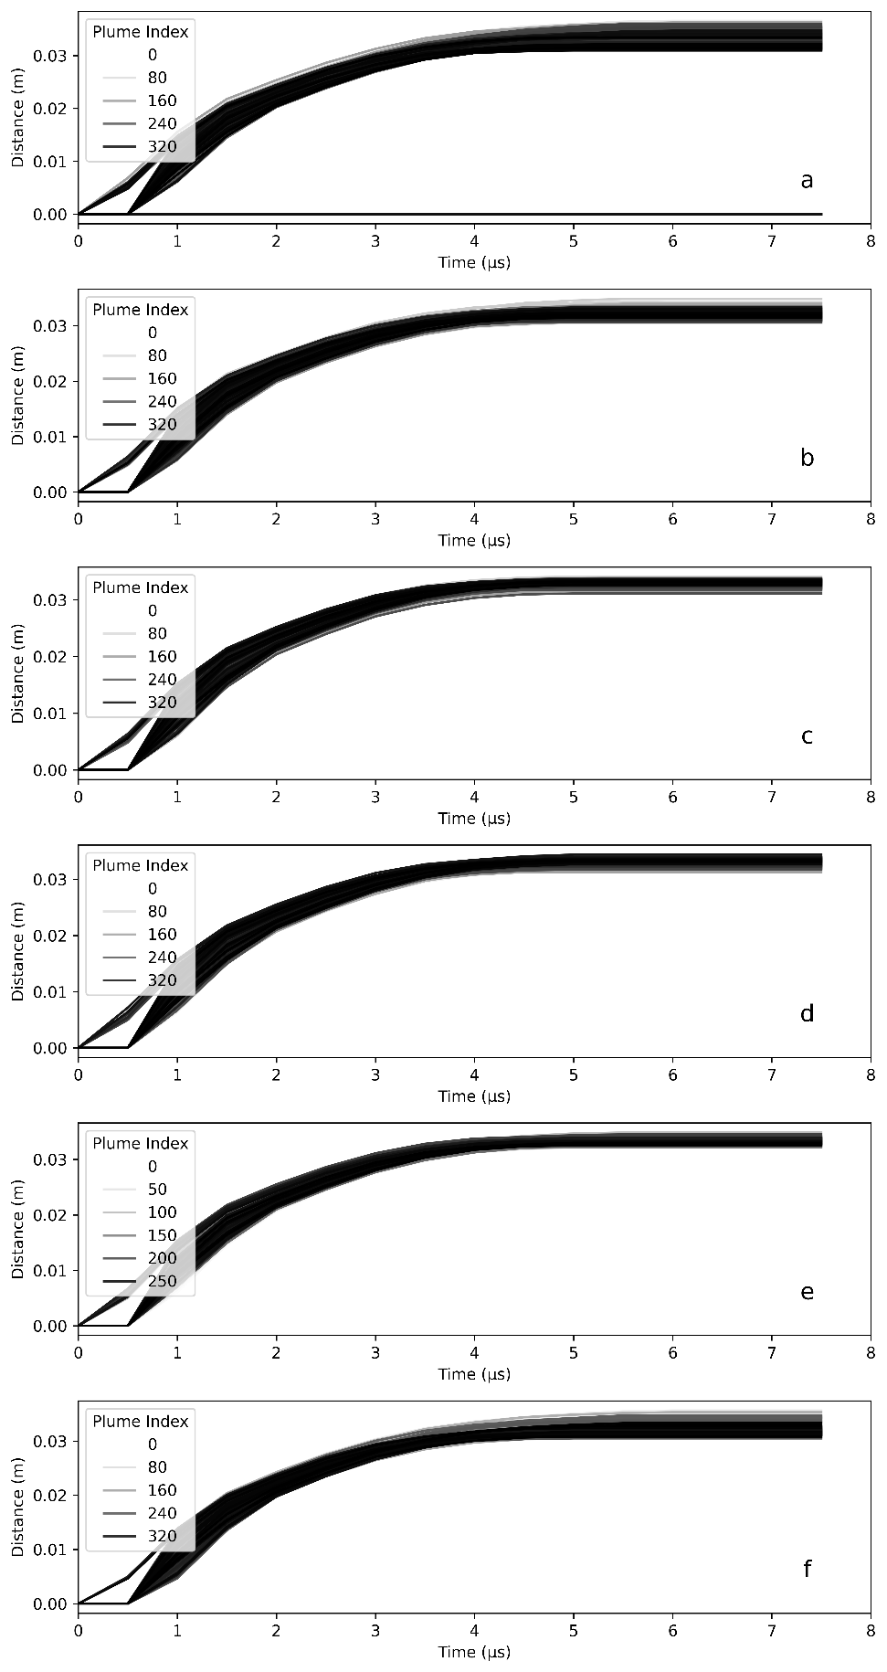

**Figure S10: a-f** Plume distance with time with indexed plume history for sample t1-t5/s1 and s2.

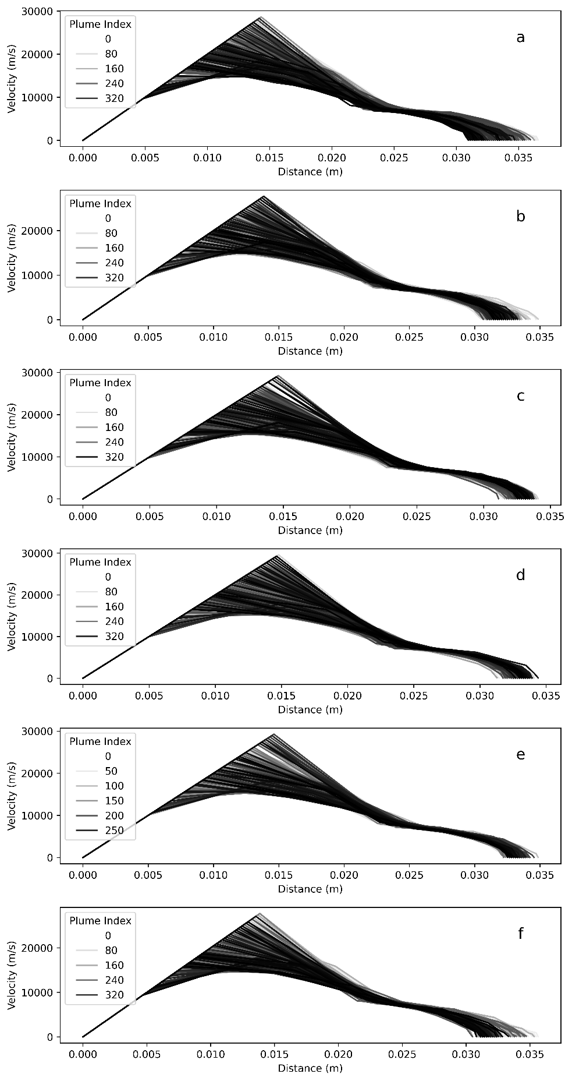

**Figure S11 a-f** Plume velocity with distance with indexed plume history for sample t1-t5/s1 and s2.